|  |
| --- |
| \\hps-inst-home.hps.tld\homes\eamos\Desktop\logo .png**David Paterson School Code of Conduct**\\hps-inst-home.hps.tld\homes\eamos\Desktop\logo .png  **2019-2020** |

|  |
| --- |
| ***David Paterson School Mission Statement*** |

***The David Paterson IB PYP Candidate Elementary School is committed to building partnerships with students, staff, parents and the community to develop life-long learners. Through rigorous inquiry and empowerment, our learners will be equipped to become college and career ready and*** ***exemplify attributes and skills of a 21st century global citizen.***

|  |
| --- |
| ***David Paterson School Motto*** |

***Every Child, Every Chance, Every Day!***

***Introduction***

***Our school learning community promotes the development of explicit attributes and the expectation of socially responsible behavior. The ten Attributes of the IB Learner Profile characterize a global-minded citizen and defines the type of learner we inspire to empower.***

**Balanced:**We understand the importance of balancing different aspects of our lives - intellectual, physical, and emotional - to achieve well-being for ourselves and others. We recognize our interdependence with other people and with the world in which we live.

**Caring:**We show empathy, compassion and respect. We have a commitment to service, and we act to make a positive difference in the lives of others and in the world around us.

**Communicators:**We express ourselves confidently and creatively in more than one language and in many ways. We collaborate effectively, listening carefully to the perspectives of other individuals and groups.

**Inquirers:**We nurture our curiosity, developing skills for inquiry and research. We know how to learn independently and with others. We learn with enthusiasm and sustain our love of learning throughout life.

**Knowledgeable:** We develop and use conceptual understanding, exploring knowledge across a range of disciplines. We engage with issues and ideas that have local and global significance.

**Open-minded:** We critically appreciate our own cultures and personal histories, as well as the values and traditions of others. We seek and evaluate a range of points of view, and we are willing to grow from the experience.

**Principled: We** act with integrity and honesty, with a strong sense of fairness and justice, and with respect for the dignity and rights of people everywhere. We take responsibility for our actions and their consequences.

**Reflective:** We thoughtfully consider the world and our own ideas and experience. We work to understand our strengths and weaknesses in order to support our learning and personal development.

**Risk-takers**: We approach uncertainty with forethought and determination; we work independently and cooperatively to explore new ideas and innovative strategies. We are resourceful and resilient in the face of challenges and change.

**Thinkers:**We use critical and creative thinking skills to analyze and take responsible action on complex problems. We exercise initiative in making reasoned, ethical decisions.

**Student Responsibilities**

***As members of our school learning community at the David Paterson School students are expected to follow all essential agreements; in our school, classrooms, lunchroom, playground, hallways, and bathrooms.***

***Hallway Essential Agreements***

***We agree to:***

* ***Respect ourselves, others, and our school by using manners***
* ***Always use a soft or whisper voice***
* ***Walk on the right side of the hallway***
* ***Follow directions the first time they are given***
* ***Keep our hands, feet, and other objects to ourselves***
* ***Leave doorways unblocked***

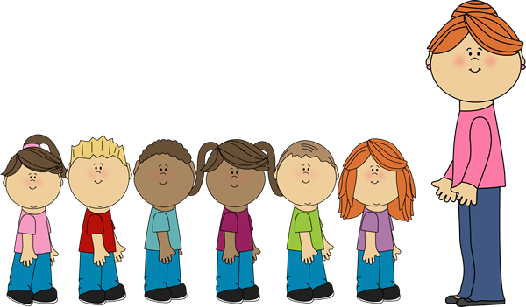

***Bathroom Essential Agreements***

***We agree to:***

* ***Respect ourselves, others, and our school by using manners in the bathroom***
* ***Flush after use***
* ***Keep clean by washing our hands***
* ***Use paper towels correctly and dispose of them in the wastebasket***
* ***Shut the water off when we are finished***
* ***Use the restroom in a timely manner***
* ***keep unnecessary comments to ourselves while knowing bathrooms are a personal space***

 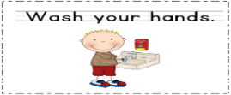

***Lunchroom Essential Agreements***

***We agree to:***

1. ***Be respectful to adults and peers***
2. ***Use our hands and voice to show we care about others***
3. ***Use inside voices***
4. ***Eat our food without talking***
5. ***Appreciate the food that we have***
6. ***Clean up after we eat and keep the multi-purpose room the way we found it***
7. ***Remain seated unless there is an emergency, or we are asked to do so***
8. ***Communicate and ask permission before leaving the multipurpose room***
9. ***Raise our hand when we need assistance, plastic ware, condiments, straws and other items.***
10. ***Have a balanced and relaxed lunch period.***

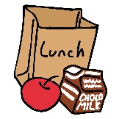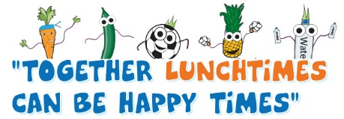

***Playground Essential Agreements***

*We agree to:*

1. *Be caring by smiling, helping, sharing, and playing with one another.*
2. *Be principled by doing the right thing, even if it is hard.*
3. *Be a communicator by talking and listening to each other.*
4. *Be knowledgeable by knowing and practicing rules that will keep us safe.*
5. *Be balanced by playing with lots of different people.*
6. *Be open minded by accepting other’s ideas, strengths and weaknesses.*
7. *Be a thinker by stopping and reflecting before making a choice.*
8. *Be a risk taker by choosing different people to play with and by trying a new game or idea.*
9. *Be an inquirer by asking questions about things that you are new to or unsure of.*
10. *Be reflective by thinking about my actions and how it impacts myself and others.*

***Positive Behavior Interventions and Supports (PBIS)***

At the David Paterson School, we have a school-wide Positive Behavior initiative. Our “Hooray for AAA Celebrating **A**ttributes, **A**ctions, and **A**ctions “promotes student accountability and will exemplify attributes and skills of a 21st century global citizen. Classroom, grade level and school wide events will be ongoing to foster an environment with empowerment and global-mindedness.

In addition, we hold special recognition events and partnerships with community organizations. Our students are celebrated throughout each day and year with special events including but not limited to: Assemblies, contests, trips, Field Day, Family Fun Day, clubs, award ceremonies, student of the month, bring your parent to school days, and career day.

